Study of Ambient Air Quality Variation Using Mobile Monitoring Techniques

B.Tech. Project Report
by
Dhaval Nikam 2206326

Faculty Adviser
Dr. Thaseem Thajudeen



School of Mechanical Sciences Indian Institute of Technology Goa

Declaration

I declare that this written submission represents my ideas in my own words and where others’ ideas or words have been included, I have adequately cited and referenced the original sources.

I understand that any violation of the above will be cause for disciplinary action by the Institute and can also evoke penal action from the sources which have thus not been properly cited or from whom proper permission has not been taken when needed.



(Signature)

Dhaval Nikam

(Name of the student)

2206326

(Roll No.)

Date: 16/04/26

Abstract
Air pollution, particularly due to fine particulate matter (PM_{2.5}), has become a significant environmental and public health concern, especially in urban and semi-urban regions. PM_{2.5}, defined as particles with an aerodynamic diameter of 2.5 µm or less, can penetrate deep into the respiratory system and pose serious health risks. Therefore, understanding its spatial and temporal variation is essential for effective air quality assessment and management.
In this study, a mobile air quality monitoring approach was adopted to analyze the variation in ambient air quality in Ponda, Goa. The monitoring system consisted of multiple low-cost PMS5003 sensors integrated with Arduino microcontrollers, along with research-grade instruments such as the DustTrak DRX and Optical Particle Sizer (OPS). A GPS module was used to record location data, enabling spatial mapping of pollutant concentrations. Data collection was carried out over multiple days during both morning and evening periods using a vehicle-based setup, covering diverse regions including campus, residential, traffic-dominated, forest, and village areas. The results indicate significant spatial and temporal variations in PM_{2.5} mass concentration and particle number concentration across the study area. Higher pollution levels were observed in traffic-prone and densely populated regions, while lower concentrations were found in less congested and vegetated areas. Comparative analysis between weekdays and weekends showed higher concentrations during weekdays due to increased vehicular movement and human activities. Furthermore, particle number concentration analysis revealed a dominance of fine particles, particularly in the 0.3–1 µm size range, with a decreasing trend observed as particle size increased. Overall, the study demonstrates that mobile monitoring is an effective method for capturing high-resolution, location-specific air quality data. The combined analysis of mass and number concentration provides a comprehensive understanding of particulate matter characteristics and highlights the influence of traffic patterns, land use, and population density on air quality variation.

Table of Contents
Declaration 2
Abstract 3
List of Figures 5
List of Tables 6
Chapter 1: Introduction 7
Chapter 2: Methodology 9
2.1 Study Area 9
2.2 Research-Grade Instruments and Low-Cost Sensors Used in the Monitoring Campaign 9
2.2.1 DustTrak DRX (PM Monitor) 9
2.2.2 Optical Particle Sizer (OPS) 9
2.2.3 PMS5003 Sensor 10
2.3 Vehicle add-on mobile monitoring setup 11
2.4 Field sampling strategy 12
Chapter 3: Results and Discussion 14
3.1: Population density variation in Goa ((Population/m²)) 14
3.2: Land use land cover 15
3.3: Local Variation of PM2.5 concentration in different local areas 16
3.4 Local Variation of number concentration from fine and coarser particles in different local areas 17
3.4.1 Particle Number Distribution Across Size Ranges 17
3.4.2 Variation of 0.3–0.5 µm Particle Concentration (Weekdays vs Weekends) 18
3.4.3 Variation of 0.5–1 µm Particle Concentration (Weekdays vs Weekends) 19
3.4.4 Variation of 1–2.5 µm Particle Concentration (Weekdays vs Weekends) 20
3.4.5 Total Particle Concentration Variation 21
Chapter 4: Conclusion 22
References 23

List of Figures
Figure: 2.1: Study area of Ponda………………………………………………………………….9
Figure: 2.2: (a) Dust Tracker (b) Optical particle counters………………………………………….........10
Figure: 2.3: PMS5003 sensor……………………………………………………………………...11
Figure: 2.4: (a)Setup Diagram (b)Actual Setup…………………………………..........................12
Figure: 3.1: Population density variation across selected regions in Goa, including Panjim, Ponda, and Madgaon…………………………………………………………………………………………………….15
Figure: 3.2: Land use and land cover (LULC) map of Goa showing different categories such as built-up areas, vegetation, agricultural land, and water bodies………………………………………………………16
Figure 3.3: Variation in PM2.5 concentration across different locations in Ponda…………………………………………………………………………………………………….….17
Figure 3.4: Comparison of PM2.5 concentrations across different areas of Ponda during (a)weekdays and (b)weekends…………………………………………………………………………………………………17
Figure 3.5: Overall variation of particle number concentration in local areas of Ponda during measurement period: (a) 0.3–0.5 µm, (b) 0.5–1 µm, (c) 1–2.5 µm, and (d) total number concentration (0.3–10µm)………………………………………………………………………………………………….........18
Figure 3.6: Overall variation of particle number concentration in the 0.3–0.5 µm size range across local areas of Ponda during the measurement period, comparing (a) weekdays and (b) weekends……………...19
Figure 3.7: Overall variation of particle number concentration in the 0.5–1 µm size range across local areas of Ponda during the measurement period, comparing (a) weekdays and (b) weekends……………………20
Figure 3.8: Overall variation of particle number concentration in the 1–2.5 µm size range across local areas of Ponda during the measurement period, comparing (a) weekdays and (b) weekends……………………21
Figure 3.9: Overall variation of total particle number concentration in the 0.3–10 µm size range across local areas of Ponda during the measurement period, comparing (a) weekdays and (b) weekends……………....................................................................................................................................21

List of Tables
Table 2.1: Schedule of Data Collection During the Monitoring Campaign

Chapter 1: Introduction
Air pollution has become a major concern in urban environments, primarily due to the increasing concentration of particulate matter (PM) generated from traffic emissions and other anthropogenic sources. These fine particles significantly affect air quality and pose serious risks to human health. In densely populated regions, exposure to particulate matter is especially high due to continuous vehicular movement and urban activities.[1]
Particulate matter consists of a mixture of solid particles and liquid droplets suspended in the air, including dust, metals, organic compounds, and other harmful substances. Among these, fine particles such as PM2.5, defined as particulate matter with an aerodynamic diameter of 2.5 micrometers or less are of particular concern because of their ability to penetrate deep into the respiratory system and even enter the bloodstream. Prolonged exposure to such particles has been associated with various health issues, including respiratory diseases, cardiovascular problems, and increased mortality rates. Traditional air quality monitoring is typically carried out using fixed monitoring stations, which provide general information about pollution levels in a specific area. However, these stationary measurements often fail to capture local variations in pollutant concentrations, especially those experienced by individuals during daily activities such as commuting. Studies have shown that pollution exposure can vary significantly over short distances and time periods, making it necessary to adopt more dynamic measurement approaches [2]. In recent years, mobile air quality monitoring has emerged as an effective method for capturing real-time and location-specific pollution data. By using portable sensors mounted on vehicles, it is possible to measure particulate matter concentrations along different routes and under varying environmental conditions. This approach allows for a more accurate assessment of human exposure to air pollutants, particularly in traffic-dominated environments where pollutant levels fluctuate rapidly [3].
Therefore, understanding the spatial and temporal variation of particulate matter through mobile monitoring techniques is essential for improving air quality assessment, identifying pollution hotspots, and supporting the development of effective environmental management strategies.
Objective of Study:
- To measure real-time PM2.5 concentrations using portable air quality sensors.
- To measure particle number concentration along with mass concentration for a more detailed assessment of air quality.
- To conduct vehicle-based data collection across different locations in Ponda, Goa.
- To analyze the spatial variation of particulate matter across different routes.
- To study the temporal variation in PM2.5 levels during morning and evening periods.
- To identify possible factors influencing air quality, such as traffic density, road conditions, and human activities.

Chapter 2: Methodology

Study Area
The study was conducted in Ponda, Goa, which is a semi-urban region characterized by a mix of residential, commercial, and traffic-dominated areas. The selection of this area was based on its varying traffic density and human activities, making it suitable for analyzing spatial and temporal variations in air quality. The study area includes major roads and intersections where vehicular emissions are expected to influence particulate matter concentrations.
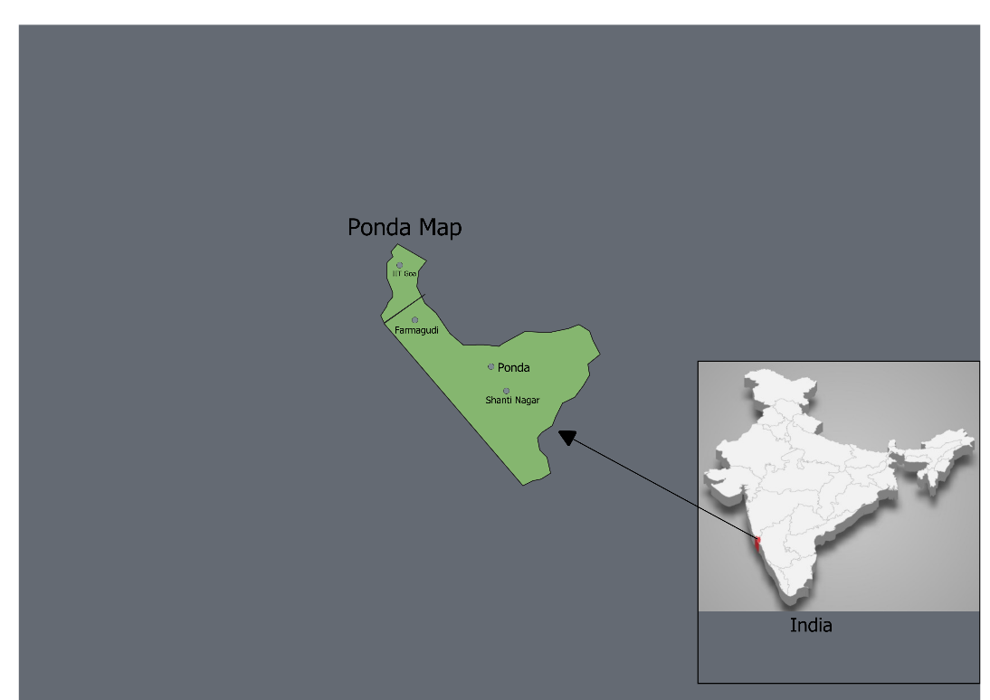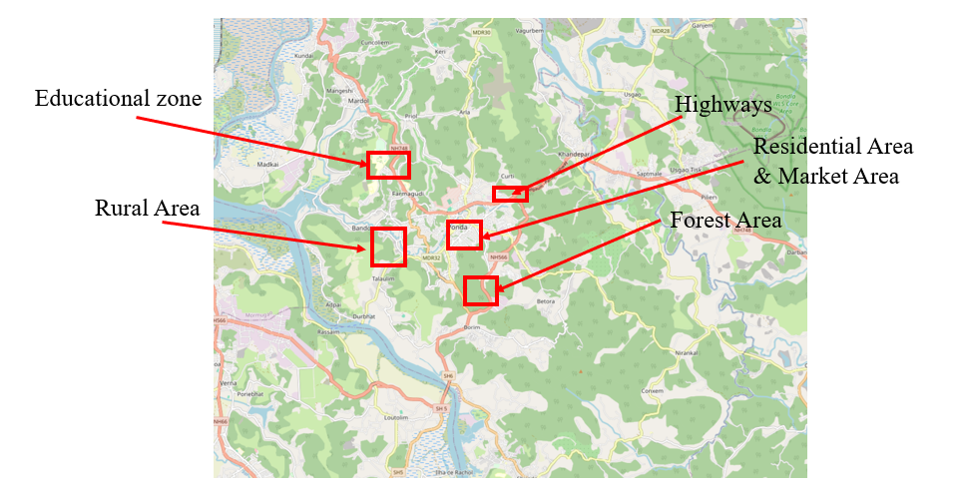
Figure: 2.1: Study area of Ponda

2.2 Research-Grade Instruments and Low-Cost Sensors Used in the Monitoring Campaign

2.2.1 DustTrak DRX (PM Monitor)
The DustTrak DRX is a real-time aerosol monitor used to measure particulate matter mass concentration, including PM1, PM2.5, and PM10. It operates on the principle of laser light scattering, where the intensity of scattered light is used to estimate particle mass concentration. The instrument provides continuous and high-resolution data, making it suitable for field-based air quality monitoring studies.

2.2.2 Optical Particle Sizer (OPS)
The Optical Particle Sizer is used to measure particle number concentration and size distribution across different particle size ranges. It classifies particles into multiple size bins (e.g., 0.3–10 µm) using optical scattering techniques. The instrument helps in understanding particle characteristics by providing detailed information on particle count and size distribution.
The combined use of DustTrak DRX and Optical Particle Sizer enables simultaneous measurement of both mass concentration and number concentration, providing a comprehensive assessment of particulate matter in ambient air.
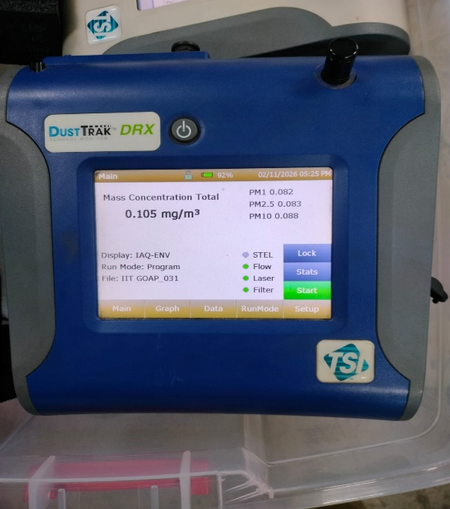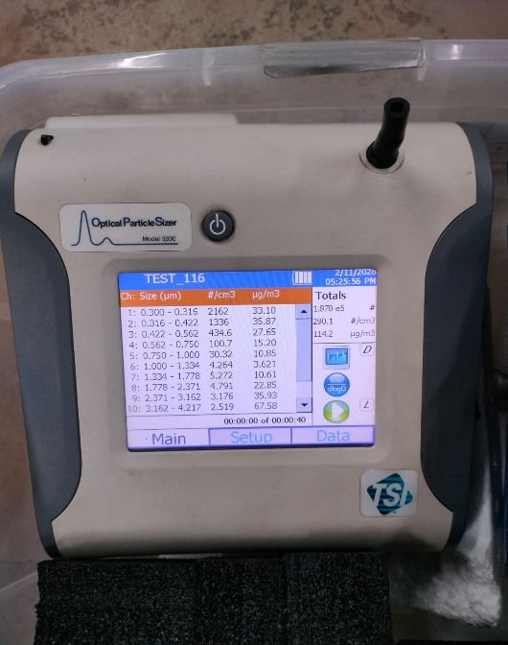
Figure: 2.2: (a) Dust Tracker (b) Optical particle counters

2.2.3 PMS5003 Sensor
The PMS5003 is a low-cost optical particle sensor used to measure particulate matter concentrations, including PM1, PM2.5, and PM10, along with particle number concentration. It operates on the principle of laser light scattering, where particles passing through a laser beam scatter light, and the detected signal is used to determine particle size and count. The sensor includes an internal fan that draws ambient air into the measurement chamber, enabling continuous real-time monitoring of airborne particles across different size ranges (0.3–10 µm).

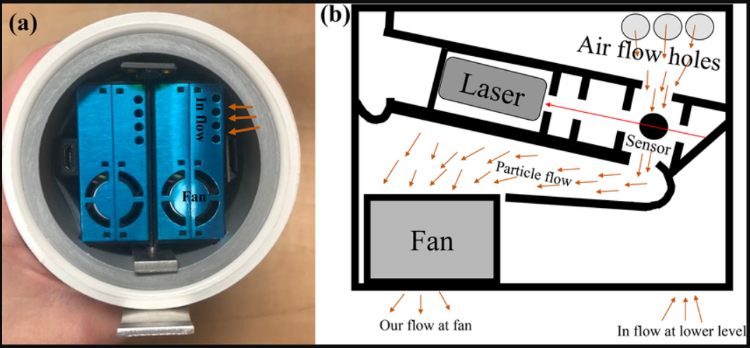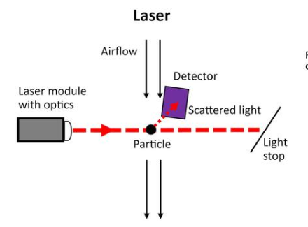
Figure: 2.3: PMS5003 sensor

2.3 Vehicle add-on mobile monitoring setup
The vehicle add-on mobile monitoring setup was designed to enable real-time and spatially resolved air quality measurements. The system consists of four PMS5003 low-cost sensors mounted in different directions to capture particulate matter concentrations from multiple orientations, thereby improving the representativeness of ambient measurements during vehicle movement. These sensors were integrated with Arduino microcontrollers for continuous data acquisition and processing. In addition, a GPS module was incorporated into the system to record the geographical location of each measurement, allowing for accurate mapping and spatial analysis of air quality data.
To ensure data reliability and accuracy, research-grade instruments such as the DustTrak DRX and Optical Particle Sizer (OPS) were also included in the setup. The DustTrak was used to obtain precise measurements of PM2.5 mass concentration, while the Optical Particle Sizer provided detailed information on particle number concentration and size distribution. The use of these instruments alongside low-cost sensors allowed for validation and comparison of measurements, enhancing the overall quality of the dataset. All components were assembled in a portable enclosure and powered using a power bank, making the system suitable for mobile deployment. The complete setup, as shown in Figure 2.4, was mounted on a vehicle to collect air quality data across different locations in the study area, enabling effective analysis of spatial and temporal variations in particulate matter concentrations.

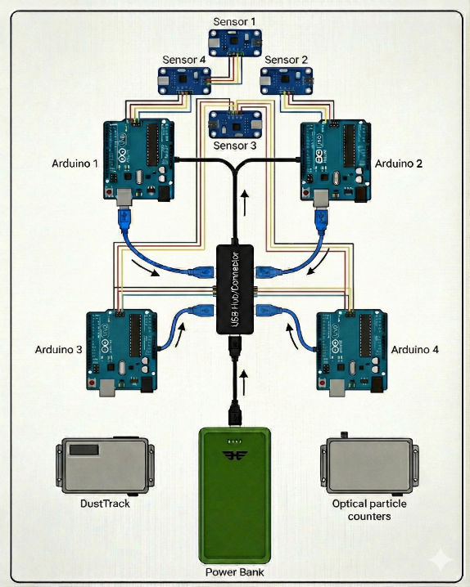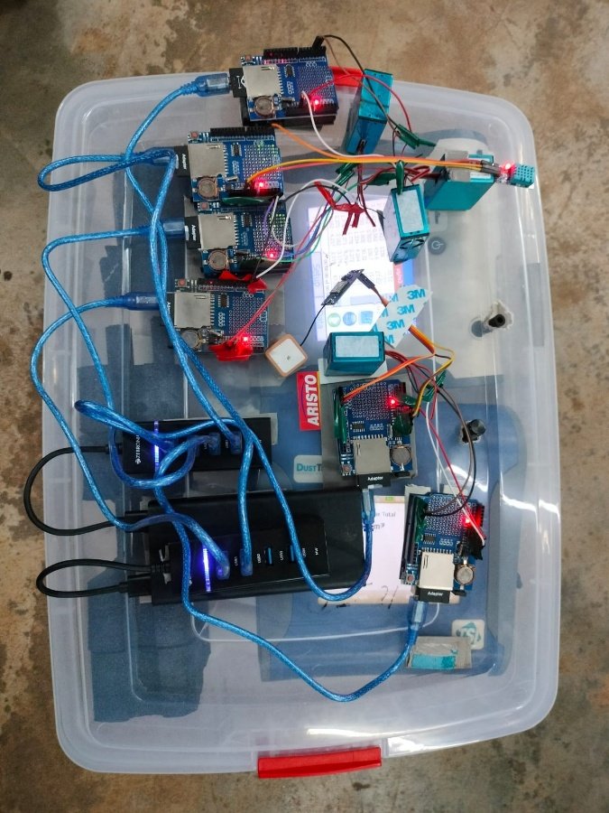
Figure: 2.4: (a)Setup Diagram (b)Actual Setup

Field sampling strategy

Date | Day | Timings | Avg. Time taken
31/01/26 | Saturday | Evening | 1 hour 45 minutes
01/02/26 | Sunday | Morning | 1 hour 45minutes
01/02/26 | Sunday | Evening | 1 hour 45minutes
02/02/26 | Monday | Morning | 1 hour 45minutes
02/02/26 | Monday | Evening | 1 hour 45minutes
03/02/26 | Tuesday | Morning | 1 hour 45minutes
03/02/26 | Tuesday | Evening | 1 hour 45minutes
04/02/26 | Wednesday | Morning | 1 hour 45minutes
04/02/26 | Wednesday | Evening | 1 hour 45minutes
05/02/26 | Thursday | Morning | 1 hour 45minutes
05/02/26 | Thursday | Evening | 1 hour 45minutes
06/02/26 | Friday | Morning | 1 hour 45minutes
06/02/26 | Friday | Evening | 1 hour 45minutes
07/02/26 | Saturday | Morning | 1 hour 45minutes
Table 2.1: Schedule of Data Collection During the Monitoring Campaign

The field sampling was carried out systematically during both morning and evening periods to capture temporal variations in air quality. Morning measurements were typically initiated around 6:30 AM, starting from the campus region and progressively covering residential areas of Ponda, followed by traffic-dominated zones, forest regions, and nearby village areas. The monitoring route was designed to include diverse land-use types in order to capture variations in particulate matter concentrations across different environments. The sampling session concluded around 8:15 AM at the same starting point, completing a full loop of the study area. A similar procedure was followed during evening sessions to ensure consistency in data collection.
The entire monitoring setup was mounted on a vehicle, with the equipment carried on a bike while the observer was seated behind the driving assistant, enabling continuous real-time data acquisition during movement. This mobile approach allowed for high-resolution spatial mapping of air quality across different locations. The detailed schedule of data collection, including dates, timings, and duration, is presented in Table 2.1.

Chapter 3: Results and Discussion

The results obtained from the mobile air quality monitoring campaign are presented and discussed in this chapter. The analysis is based on both PM2.5 mass concentration and particle number concentration measured across different locations in Ponda, Goa. The results are illustrated using spatial maps, graphs, and comparative plots to understand variations in air quality. The graphical representation of data enables the identification of spatial variations in pollutant levels across different regions, as well as temporal variations between morning and evening periods. In addition, comparisons between weekdays and weekends have been carried out to assess the influence of traffic patterns and human activities on particulate matter concentrations. Furthermore, particle number concentration has been analyzed for different size ranges to understand the distribution of fine and coarse particles in the ambient environment. The combined analysis of mass concentration and number concentration provides a comprehensive understanding of air pollution characteristics and helps in identifying potential pollution hotspots.

3.1: Population density variation in Goa ((Population/m²))
The figure shows the spatial variation of population density across different regions of Goa, with higher concentrations observed in urban centers such as Panjim and Madgaon. In contrast, Ponda exhibits moderate population density, reflecting its semi-urban characteristics. Regions with higher population density are typically associated with increased vehicular movement and human activities, which can contribute to elevated levels of air pollution. This variation in population density provides important context for understanding the distribution of PM2.5 concentrations observed in the study and suggests that population density plays a significant role in influencing spatial variations in air quality.
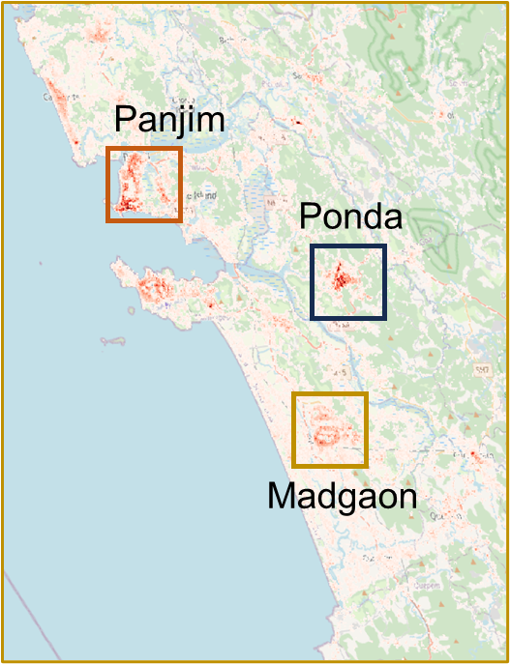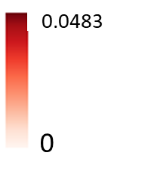
Figure: 3.1: Population density variation across selected regions in Goa, including Panjim, Ponda, and Madgaon.

3.2: Land use land cover
The land use and land cover (LULC) map illustrates the spatial distribution of different surface types across Goa, including built-up areas, forests, agricultural land, and water bodies. Urban and built-up regions are primarily concentrated in coastal areas such as Panjim and Madgaon, while the eastern part of the region is dominated by dense vegetation and forest cover. Ponda shows a mix of agricultural land and moderate built-up areas, reflecting its semi-urban nature. The variation in land use plays an important role in influencing air quality, as regions with higher urbanization and traffic activity tend to exhibit higher particulate matter concentrations, whereas vegetated areas generally contribute to lower pollution levels due to natural filtration effects.
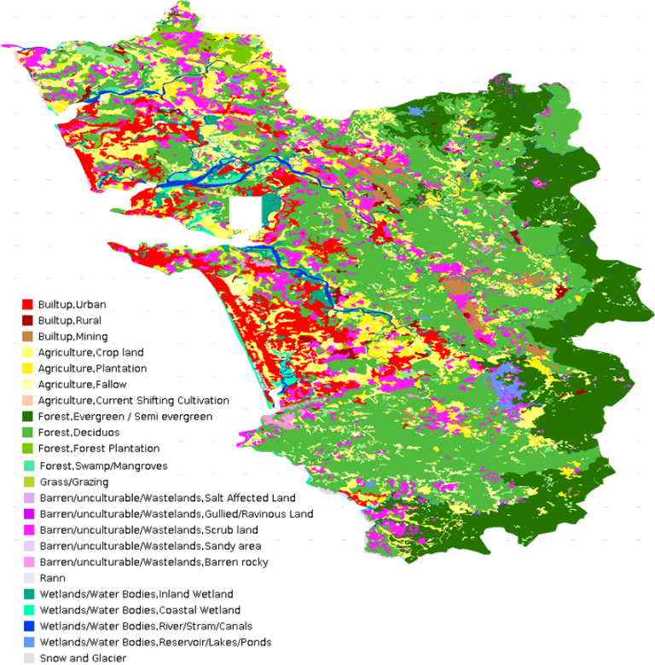
Figure: 3.2: Land use and land cover (LULC) map of Goa showing different categories such as built-up areas, vegetation, agricultural land, and water bodies

3.3: Local Variation of PM2.5 concentration in different local areas
The PM2.5 concentration maps illustrate significant spatial variation in air quality across different locations in Ponda. As shown in Figure 3.3, higher concentrations are observed in specific regions, particularly along major roads and traffic-prone areas, indicating the strong influence of vehicular emissions on air pollution levels. In contrast, relatively lower concentrations are seen in less congested and more vegetated areas, suggesting better dispersion and reduced emission sources.
The comparison between weekdays and weekends, as shown in Figure 3.4, further highlights the impact of human activities on air quality. Higher PM2.5 concentrations are generally observed during weekdays, especially in urban and traffic-dominated regions, due to increased vehicular movement and routine activities. On the other hand, weekend data shows comparatively lower concentrations in most areas, reflecting reduced traffic intensity and lower emission levels. However, certain localized regions still exhibit elevated concentrations, indicating the presence of persistent pollution sources.
Overall, the results demonstrate clear spatial and temporal variations in PM2.5 levels, with traffic patterns, population density, and land use playing a significant role in influencing air quality across the study area.
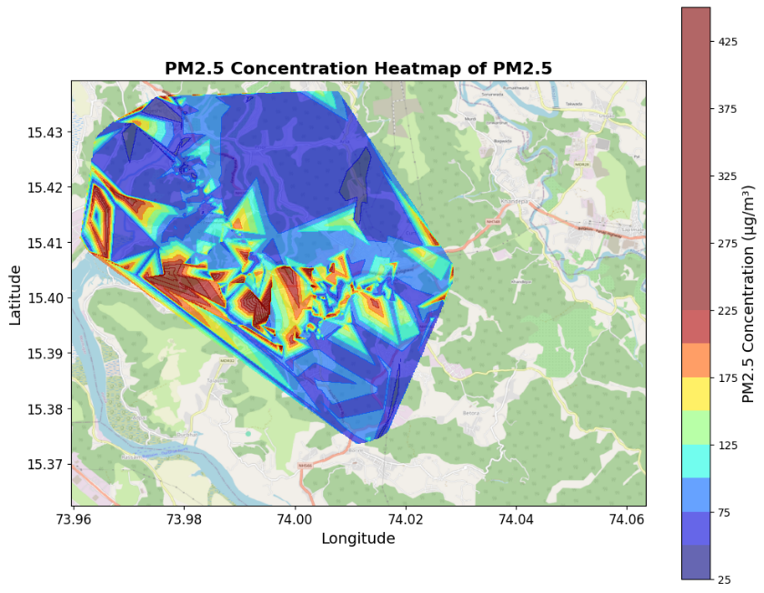
Figure 3.3: Variation in PM2.5 concentration across different locations in Ponda

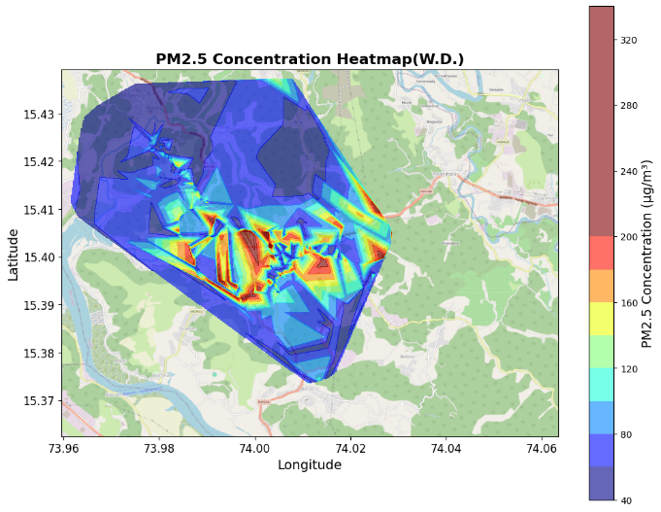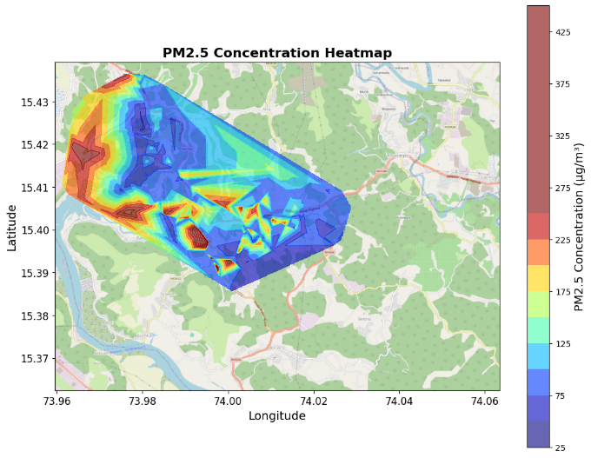
Figure 3.4: Comparison of PM2.5 concentrations across different areas of Ponda during (a)weekdays and (b)weekends.

3.4 Local Variation of number concentration from fine and coarser particles in different local areas

3.4.1 Particle Number Distribution Across Size Ranges
The particle number concentration maps reveal significant variation across different size ranges in the study area. As shown in Figure 3.5, higher concentrations are predominantly observed in the smaller particle size ranges (0.3–0.5 µm and 0.5–1 µm), indicating the dominance of fine particles in the ambient air. These fine particles are mainly associated with combustion sources such as vehicular emissions and are widely distributed along major roads and high-activity regions. In contrast, larger particles in the 1–2.5 µm range exhibit relatively lower concentrations and are more localized, likely originating from dust and mechanical processes. The total number concentration map (0.3–10 µm) further highlights regions with consistently higher particle counts, which correspond to areas with increased traffic movement and human activities. A clear decreasing trend in particle concentration with increasing particle size is observed, confirming that fine particles contribute more significantly to the overall particle count. Additionally, the comparison between weekdays and weekends shows higher number concentrations during weekdays, particularly for smaller particle sizes, due to increased vehicular emissions. Overall, the results demonstrate that fine particles dominate the ambient environment in Ponda, with strong spatial variation influenced by traffic patterns and local activities, emphasizing the importance of analyzing particle size distribution along with mass concentration for a comprehensive assessment of air quality.
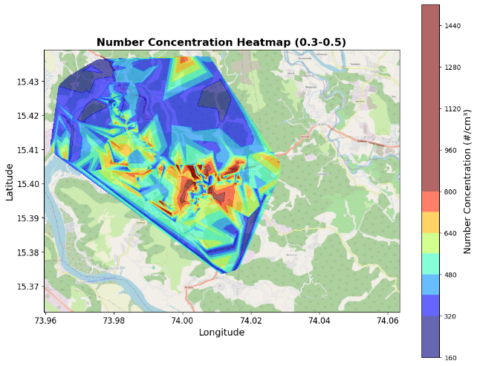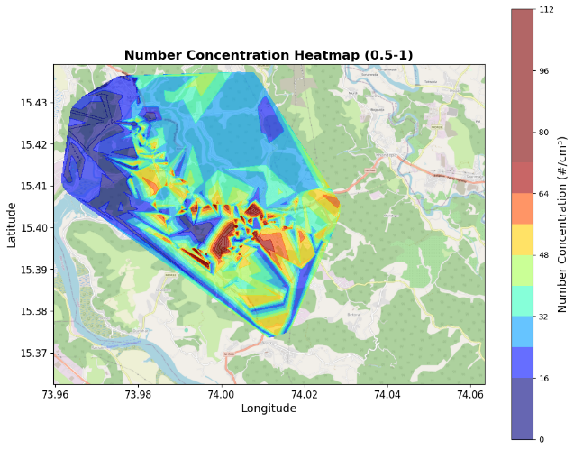
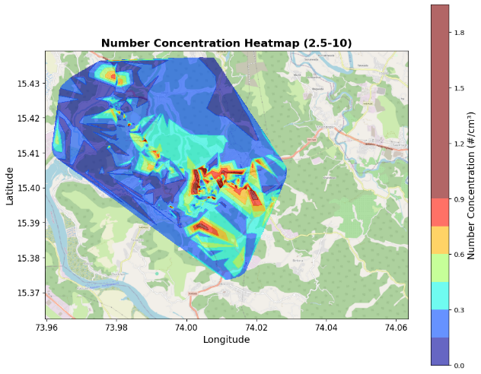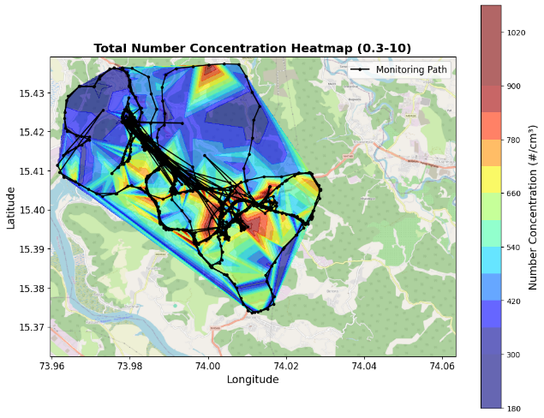
Figure 3.5: Overall variation of particle number concentration in local areas of Ponda during the measurement period: (a) 0.3–0.5 µm, (b) 0.5–1 µm, (c) 1–2.5 µm, and (d) total number concentration (0.3–10 µm)

3.4.2 Variation of 0.3–0.5 µm Particle Concentration (Weekdays vs Weekends)
The comparison of particle number concentration in the 0.3–0.5 µm size range between weekdays and weekends shows noticeable temporal variation. Higher concentrations are generally observed during weekdays, particularly along major roads and high-traffic areas, indicating the strong influence of vehicular emissions and routine human activities. In contrast, weekend concentrations are comparatively lower in most regions, reflecting reduced traffic intensity and lower emission sources. However, certain localized areas continue to show elevated values even during weekends, suggesting the presence of persistent pollution sources. Overall, the results indicate that fine particles dominate the ambient air and are highly influenced by traffic patterns and daily activity cycles.
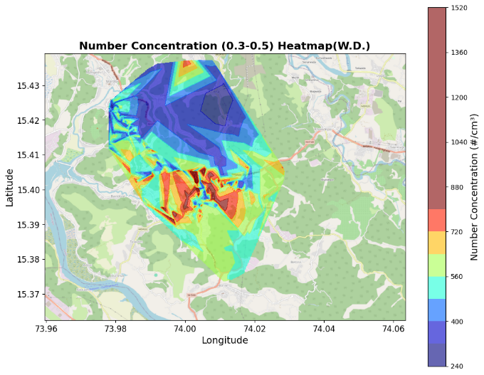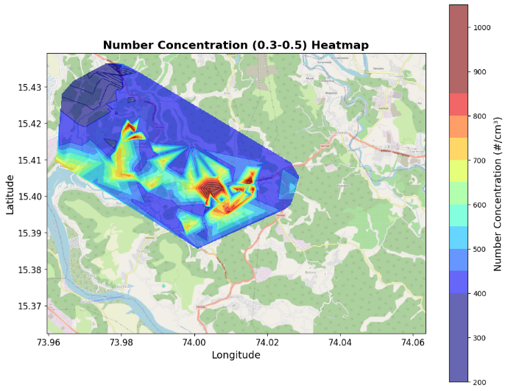
Figure 3.6: Overall variation of particle number concentration in the 0.3–0.5 µm size range across local areas of Ponda during the measurement period, comparing (a) weekdays and (b) weekends.

3.4.3 Variation of 0.5–1 µm Particle Concentration (Weekdays vs Weekends)
The comparison of particle number concentration in the 0.5–1 µm size range between weekdays and weekends shows clear temporal variation across the study area. Higher concentrations are observed during weekdays, particularly in regions with dense traffic and increased human activity, indicating the influence of vehicular emissions and urban activities. During weekends, the concentration levels are relatively lower in most areas, reflecting reduced traffic intensity and emission sources. However, certain localized regions still exhibit moderate to high concentrations, suggesting the presence of continuous or background pollution sources. Overall, the results indicate that particles in the 0.5–1 µm size range are influenced by both traffic patterns and localized environmental conditions, though their concentration is lower compared to finer particles.

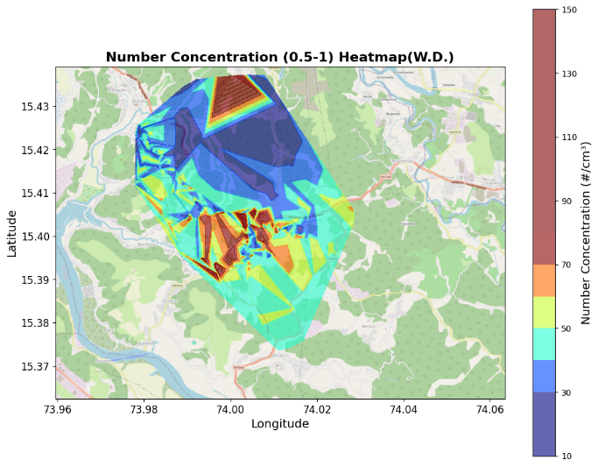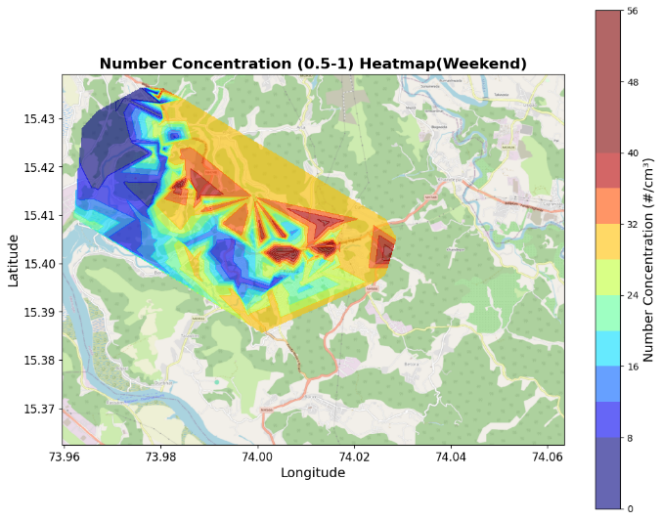
Figure 3.7: Overall variation of particle number concentration in the 0.5–1 µm size range across local areas of Ponda during the measurement period, comparing (a) weekdays and (b) weekends.

3.4.4 Variation of 1–2.5 µm Particle Concentration (Weekdays vs Weekends)
The comparison of particle number concentration in the 1–2.5 µm size range between weekdays and weekends shows relatively lower concentrations compared to finer particle sizes. During weekdays, slightly higher concentrations are observed in specific regions, particularly along areas with traffic activity and possible dust resuspension. In contrast, weekend concentrations are generally lower and more uniformly distributed across the study area, indicating reduced influence of human activities and vehicular movement. The distribution of these coarser particles appears more localized, suggesting that they are primarily generated from mechanical processes such as road dust, construction activities, and surface disturbances rather than combustion sources. Overall, the results indicate that particles in the 1–2.5 µm range are less dominant and show weaker temporal variation compared to finer particles.
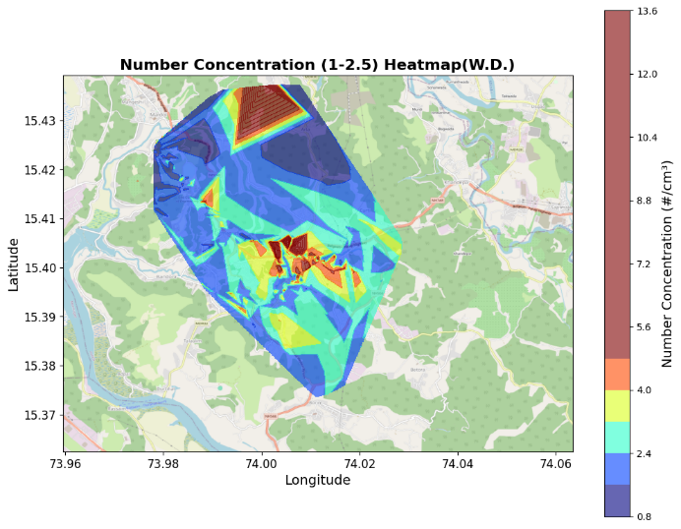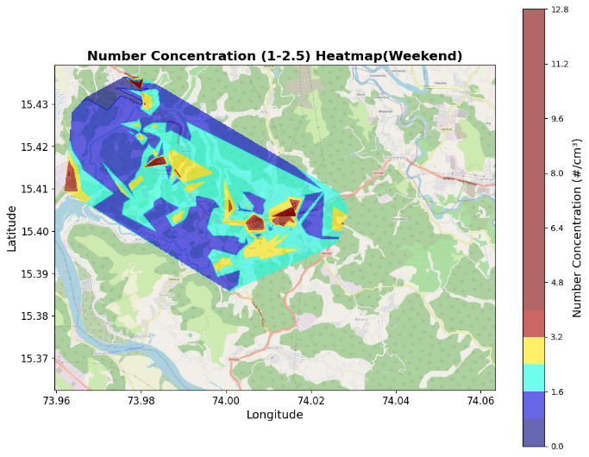
Figure 3.8: Overall variation of particle number concentration in the 1–2.5 µm size range across local areas of Ponda during the measurement period, comparing (a) weekdays and (b) weekends.

3.4.5 Total Particle Concentration Variation
The comparison of total particle number concentration in the 0.3–10 µm size range between weekdays and weekends shows a clear variation in overall particle load across the study area. Higher total concentrations are observed during weekdays, particularly in regions with dense traffic and increased human activity, indicating the combined contribution of both fine and coarse particles from various sources. In contrast, weekend concentrations are relatively lower in most areas, reflecting reduced vehicular emissions and human activities. However, certain locations continue to exhibit elevated concentrations even during weekends, suggesting the presence of persistent pollution sources. Overall, the results highlight that total particle concentration is strongly influenced by traffic patterns and local activities, with fine particles contributing significantly to the overall particle load.
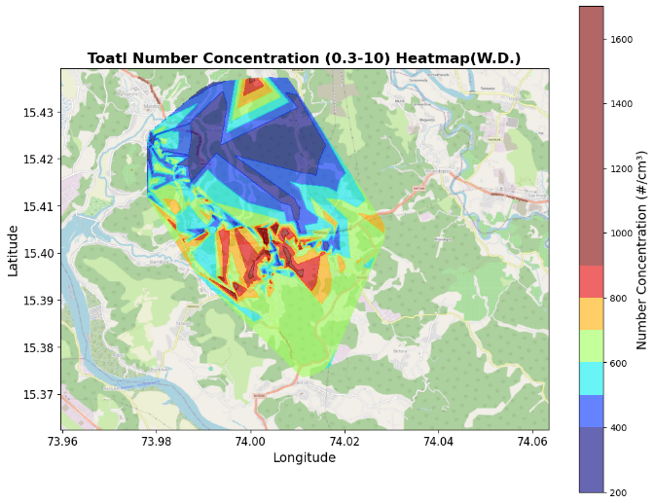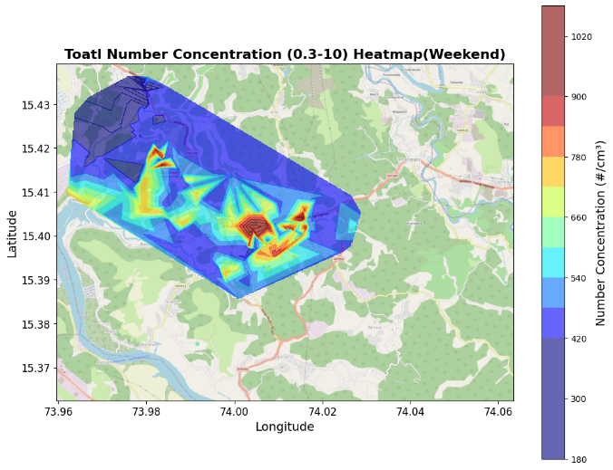
Figure 3.9: Overall variation of total particle number concentration in the 0.3–10 µm size range across local areas of Ponda during the measurement period, comparing (a) weekdays and (b) weekends

Chapter 4: Conclusion
This study successfully investigated the spatial and temporal variation of ambient air quality in Ponda, Goa using a mobile air quality monitoring approach. The integration of low-cost PMS5003 sensors with research-grade instruments such as the DustTrak DRX and Optical Particle Sizer enabled simultaneous measurement of PM2.5 mass concentration and particle number concentration, providing a comprehensive assessment of particulate matter characteristics. The results clearly demonstrate significant spatial variation in air quality across different regions, with higher PM2.5 concentrations observed in traffic-dominated and densely populated areas, while lower concentrations were found in less congested and vegetated regions. Temporal analysis revealed noticeable differences between morning and evening periods, as well as between weekdays and weekends, highlighting the strong influence of vehicular movement and human activities on pollution levels.
The analysis of particle number concentration across different size ranges indicated that fine particles, particularly in the 0.3–1 µm range, dominate the ambient environment. A decreasing trend in particle concentration with increasing particle size was observed, suggesting that combustion-related sources such as vehicular emissions play a major role in particulate pollution. In contrast, coarser particles were found to be more localized and associated with mechanical sources such as dust resuspension. Overall, the study confirms that mobile air quality monitoring is an effective and flexible method for capturing high-resolution, location-specific pollution data. The combined analysis of mass and number concentration enhances the understanding of air pollution behavior and helps in identifying pollution hotspots. The findings of this study can support improved environmental monitoring, better urban planning, and informed decision-making for air quality management.

References
[1] S. Yu et al., “Mobile monitoring of PM2.5 and exposure assessment in urban environments,” International Journal of Environmental Research and Public Health, vol. 16, no. 2, 2019.
[2] R. Kumar et al., “Advances in low-cost air quality monitoring and applications,” Environmental Science: Atmospheres, Royal Society of Chemistry, 2024.
[3] L. E. Cummings et al., “Mobile monitoring of air pollution reveals spatial and temporal variability,” Frontiers in Built Environment, 2021.
[4] J. Kerckhoffs et al., “Mobile monitoring of air pollution: Best practices and applications,” Science of the Total Environment, 2025.
[5] ResearchGate, “Picture from the bottom of the PA-II unit containing two PMS5003 sensors,” Available: https://www.researchgate.net/publication/344693171/, Accessed: 2026.

